**Experiment No. 4**

**Aim:- Main Power Supply Failure Alarm.**

**Apparatus Required:- 1. Relay(12v DC)**

**2. 2000µF and 0.1µF Capacitors**

**3. Buzzer**

**4. Bridge Diode**

**5. Transformer**

**6. 1N4007 Diode**

**7. Perfboard**

**Theory:-** There are inverters and generators to immediately start the AC power supply whenever there is a power cut but sometime when there is no backup support and we have some critical machines running to perform some important task, it’s a good idea to atleast have an alarm which notify us as soon as power goes off. In this tutorial, we will learn how to make simple **Power Failure Alarm Circuit.**This circuit can be used in many applications.

The working of the circuit is also very simple. When we turn on the supply, transformer converts the 220v AC to 12v AC. Then, the current coming from transformer is rectified by the bridge rectifier diode. The bridge rectifier consists of four rectifier diodes inside it and they are connected in series with only two diodes allowing current in a half cycle, either positive or negative. But this does not change the polarity of the output current. Hence the AC current is converted into DC.

There is one more advantage of using bridge rectifier circuit that it does not require a centre tapped transformer. After rectifying, the current is passed through a capacitor C2. This capacitor works as a filter capacitor, so that no unwanted frequency comes along with the rectification. It is sometimes called as smoothing capacitor.

Now, as the current comes to relay, it triggers and the capacitor C1 starts charging as shown below.

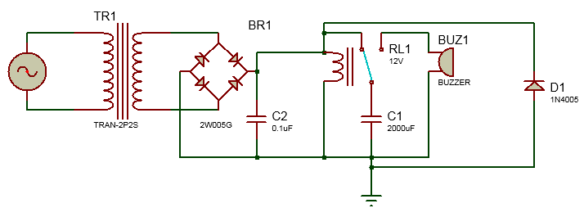

Now when the power goes off, the relay will come back to its previous position and the **buzzer-capacitor** circuit gets completed and capacitor will start discharging to buzzer so it will start beeping till the capacitor discharge completely. You can increase beeping duration by using a greater value capacitor. The current configuration gives a current of .310 Amperes across the buzzer. If you want to use this circuit with DC input then, remove the transformer and bridge rectifier circuit.

This circuit can not only be used as general **power alert system** but also can be connected with any AC appliance to check it the appliance is getting proper power supply.

**Procedure:-**

**1.**Circuit for this **Mains Supply Failure Alarm**is simple.

**2.**You just need to follow the circuit diagram and solder it up on perfboard. Firstly a **capacitor of 2000µF** is connected between the common terminal of the relay and the ground.

**3.**Then a **buzzer** is connected with positive terminal connected to normally **connected (NC) and negative terminal to the ground.**

**4.**A bridge rectifier diode is used to convert the Alternating current into Direct current. Connect the positive and negative terminal of the diode to positive and negative terminal of relay and the AC terminals to the AC power supply. Also connect a **diode (1n4007)** in reverse bias with relay.

**5.**This diode D1 is called Freewheel diode. It blocks any reverse voltage developed in relay to prevent any accident.

**6.**A **0.1µF capacitor**is used to smooth out the output DC voltage.